Kirk Delon Iverson

Apr 24, 1957 — Apr 3, 2026

Preston, Idaho
Kirk Delon Iverson, age 68, passed away April 3, 2026, in Murray, Utah. He was born April 24, 1957, to Gerold Burt Iverson and Shirley Stenquist Iverson.
He married Shauna B Bennett May 2, 1980.
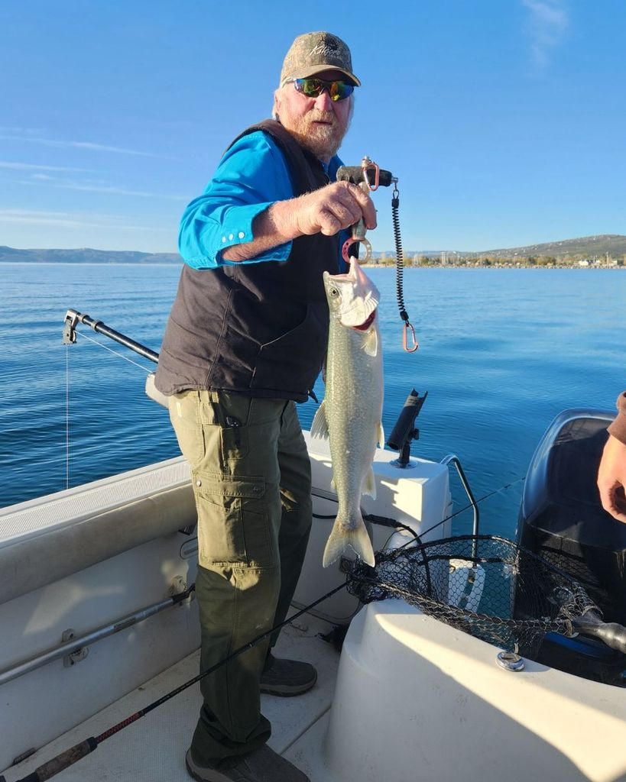
A graveside service was held Friday, April 10, 2026, at the Bear River City Cemetery.

