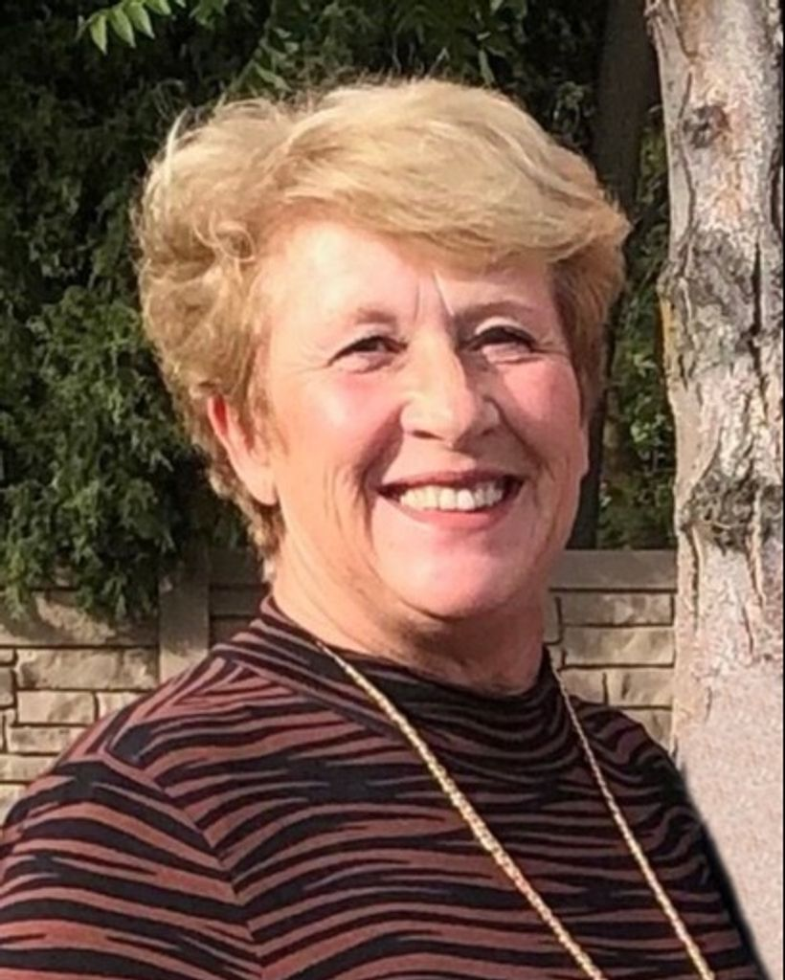

Sheila Ann Wright Benson

Nov 26, 1956 — Oct 24, 2025

Sheila Ann Wright Benson passed away peacefully on Friday, October 24, 2025, surrounded by her husband, four sons, and both of her sisters, with other loving family members close by.
Sheila was born on November 26, 1956, in Brigham City, Utah, to Marvin Scott and Merle Sackett Wright. The youngest of four girls and later joined by one brother, she liked to call herself the “middle child.” Sheila attended Central Elementary School, Box Elder Junior High, Box Elder High, and Utah Valley Community College (now Utah Valley University).
She married Joe Benson on March 10, 1977, in the Ogden Utah Temple of The Church of Jesus Christ of Latter-day Saints. Together they raised four sons, Joseph Cody Benson, Shane Gregory (Angelica) Benson, Joshua Kirk (Isabel) Benson and Cade Shawn (Snay) Benson.
Sheila loved a good time and was the most delightful mix of extrovert and introvert. She was wildly creative, wonderfully unconventional and full of life. She adored her “boys” — Joe included — and somehow became even more fun as she grew into adulthood. Because of her love and her unique way of nurturing, this Benson Clan has four wonderful sons, three amazing daughters-in-law (who are considered true daughters), seven tremendous grandkids, and one beautiful great-granddaughter.
Family always came first for Sheila, and she was happiest when surrounded by them. She was constantly looking for ways to inspire, influence, and guide her kids and grandkids in meaningful ways. She was a gifted and very insightful teacher. Above all, Sheila was a devoted and supportive wife and mother. She loved finding ways to bring the family together. She followed Joe across Utah, Idaho, Arizona, Texas, and Southern California as job opportunities arose, each time turning a new house into a home and showing her sons how to make friends and settle in with confidence.
Sheila served faithfully in many callings in The Church of Jesus Christ of Latter-day Saints, including Primary teacher, Young Women’s leader, early morning Seminary teacher in Arizona, Relief Society President, and Stake Girls Camp Director in Southern California. Most recently, she had begun serving again as Relief Society President in her ward in Ogden; and she enjoyed serving as a temple worker at the Lubbock Texas Temple. She didn’t serve to keep busy; she served because of her love for the Savior. Sheila especially loved working with the Young Women. Her years as Stake Camp Director in Palm Desert, California, were some of her happiest. She poured her creativity, humor, and energy into every detail, and the girls adored her for it. While living in Maricopa, Arizona, she taught early morning Seminary for several years — a calling that terrified her at first, but in true Sheila fashion, she threw herself into it, studied hard, and ended up loving every moment. She even made chorizo and egg breakfast burritos each week for the kids who arrived early for class — her way of making mornings more bearable. Many of those students still reach out today, remembering the no-nonsense love she showed them.
Sheila had a remarkable gift for conversation. She asked the questions others were too shy to ask and believed that most people wanted to talk about the real parts of their lives — even the hard ones.
Because of that, she often knew people in a deeper way than most ever do. She was also a woman of many talents. For several years, she traveled intermittently decorating model homes with a close-knit group of friends — a perfect mix of her love for design, laughter, and shopping. Later, with the encouragement of dear friends in Phoenix, she opened a bakery named “Marvin’s Garden”, honoring her father and his love of gardening. She poured her creativity into the business, hiring friends from her church and even a couple of her sons, finding joy in every part of it — from the baking to the community it built. She radiated a unique and uplifting, humorous light and touched many, many lives for good.

